National Animal Ethics Advisory Committee
Operational Work Plan

2024-2028

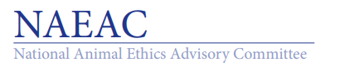
National Animal Ethics Advisory Committee
C/– Ministry for Primary Industries
P O Box 2526 Wellington 6140 New Zealand

Preamble
The National Animal Ethics Advisory Committee (NAEAC) is a statutory committee established under the Animal Welfare Act 1999 to provide independent advice to the Minister responsible for animal welfare on ethical and animal welfare issues relating to the use of animals in research, testing, and teaching (RTT). It also provides information and advice to animal ethics committees and makes recommendations to MPI concerning codes of ethical conduct under which animal research is carried out.
The current NAEAC Strategic Plan (Appendix 1) approved in 2023 for the period 2024-2028 has an overall aim to advance the ethical use and animal welfare outcomes in RTT by providing clear, high-quality, and robust advice and recommendations to the Minister and other high-level authorities as well as to animal ethics committees (AECs). Within the Strategic Plan, NAEAC identified four strategic priorities aligned with this:

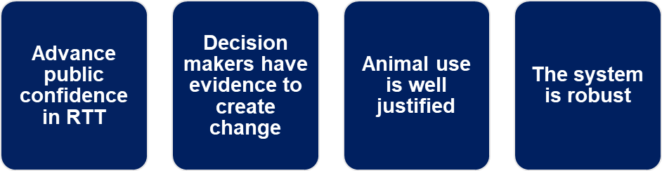

The Strategic Plan creates the framework and direction for this Operational Work Plan, utilising the four aforementioned priorities. The Operational Work Plan aims to identify milestones and resource requirements that underpin the operations of the committee and aims to ensure that NAEAC is able to fulfil its functions as outlined in the Animal Welfare Act 1999 effectively and efficiently, while recognising the diverse and changing factors that influence both the committee’s operations and its members.
As a Ministerial Advisory Committee, NAEAC is subject to strategic direction from the Minister and Associate Minister for Agriculture. The NAEAC Operational Work Plan is also subject to constraints associated with NAEAC’s own capacity and that of the MPI Secretariat.
NAEAC have indicated that for 2024, their workplan activities will be focused on the Three Rs.

Operational Objectives and Activities

Strategic Priority 1. Advance public confidence in research, testing, and teaching.

Objective:
Effectively engage to improve public awareness and understanding.

This will be achieved by:
  - Enhancing awareness of NAEAC’s role in RTT;
(b) Removing barriers and improving understanding of the RTT system;
(c) Promoting and supporting the Openness Agreement; and,
(d) Promoting a proactive approach to understanding different public views.

Operational activities:
Activity | Responsibility | Timeline | Status
- Strengthen relationship with ANZCCART | NAEAC | Ongoing
- Continued development of the NAEAC website to ensure it provides clear and accessible information and communications | Website and digital presence subcommittee | Ongoing
- Attendance of NAEAC at relevant conferences | NAEAC | Ongoing

Strategic Priority 2. Decision makers have evidence to create change.

Objective:
Evidence-based advice provided to the Minister and Director-General of MPI.

This will be achieved by:
- Making recommendations to ensure Part 6 of the Animal Welfare Act 1999 is fit for purpose;
- Recommending specific improvements to the RTT system;
- Identifying and reviewing critical and significant issues, proactively and when directed by the Minister; and,
- Remaining informed of emerging national and international developments and issues.

Operational activities:
Activity | Responsibility | Timeline | Status
- Publish the NAEAC annual report | NAEAC / Secretariat | By April each year | Completed for 2024.
- Hold joint meeting with NAWAC | NAEAC and NAWAC Chairs | To be determined | Scheduled for 7 August 2024.
- Explore a change in definition of ‘animal’ to include larval stage of zebrafish | NAEAC Chair | Ongoing
- Identify and monitor significant new issues to add to the operational plan | NAEAC | Ongoing
- Review Part 6 – is it fit for purpose? | Operation of Part 6 Subcommittee | Ongoing
- Provide advice to the Minister on any requested matter or on any significant changes that NAEAC think should be brought to the attention of the Minister | NAEAC | Ongoing
- Complete timely reviews of draft Codes of Ethical Conduct and recommendations to MPI | NAEAC | Ongoing | Six Codes for review in 2024.

Strategic Priority 3. Animal use is well justified.

Objective:

Animal ethics committees are supported in making robust decisions.

This will be achieved by:
- Supporting an efficient code of ethical conduct review process and provide advice to animal ethics committees;
- Enhancing relationships with animal ethics committees;
- Ensuring NAEAC communications are fit for purpose, responsive, and maintained;
- Promoting sharing of best practice between animal ethics committees, including advancing of the 4Rs; and
- Improving understanding of the application of Te Ao Māori principles in the RTT space.

Operational activities:
Activity | Responsibility | Timeline | Status
- Complete regional site visits with AECs and code holders | NAEAC / Secretariat | Annual – May | Completed May 2024
- Hold joint meeting with ANZCCART | NAEAC Chair | Annual | Scheduled for November 2024
- Conduct biennial AEC Chairs meetings and AEC workshops | NAEAC / Secretariat | Annual | AEC Webinar Series planned for 2024
- Create and circulate the NAEAC Newsletter | NAEAC / Secretariat | 2 -3 x yearly | April 2024 issue circulated. Next planned for July 2024.
- NAEAC members to visit AEC meetings | NAEAC | Ongoing | Members allocated to AECs for 2024.
- Ensure the GPG is updated in a timely manner in line with best practice and scientific knowledge | Publications Subcommittee | Ongoing | New version published in April 2024. Annual review process to begin again in August 2024.
- Conduct reviews of other NAEAC publications to ensure they are fit for purpose | Publications Subcommittee | Ongoing | Priority publications for 2024 identified.
- Engage with MPI during their independent collection and reporting on Animal Use Statistics to better inform the committee regarding process. | NAEAC | Annual
- Review and identify any changes needed for the CEC Application Pack | Operation of Part 6 Subcommittee | Annual | Updated Application Pack published late 2023.
- Review and identify any changes needed for the AEC Induction Pack | AEC Workshop & Training Subcommittee / Secretariat | Ongoing | Pack updated early 2024.

Strategic Priority 4. The system is robust.

Objective:
Ensure a responsible research, testing, and teaching system.

This will be achieved by:
- Identifying and prioritising system improvements;
- Ensuring effective monitoring of codes of ethical conduct and RTT activities;
- Supporting transparency initiatives for animal use in RTT; and
- Providing best-practice guidance in relation to RTT.

Operational activities:
Activities | Responsibility | Timeline | Status
- Participate in the CEC review process as required | NAEAC | Annual | Six Codes for review in 2024.
- Complete review and recommendation of Accredited Reviewers as required | NAEAC | As required
- Explore the application of the 4th R | 3Rs Subcommittee | Ongoing | 4th R SC consolidated with the 3 Rs SC.
- Explore Te Ao Māori principles relevant for the RTT space for guidance material | Mātauranga Māori Subcommittee | 2024 | Ongoing
- Promote and present the Aotearoa John Schofield 3Rs Award together with ANZCCART | NAEAC / 3Rs Subcommittee | Biennial | Budget confirmed with ANZCCART in March 2024. Award advertised in July 2024.
- Liaise with various relevant stakeholders | NAEAC / Secretariat | Ongoing

Appendix 1. NAEAC Strategic Plan 2024-2028

